**Changelog**

**SGPA3**

**Automated Process Management System**

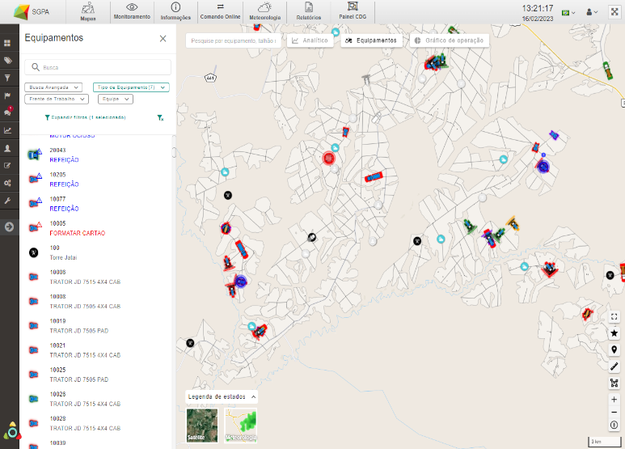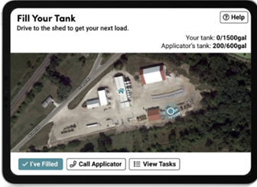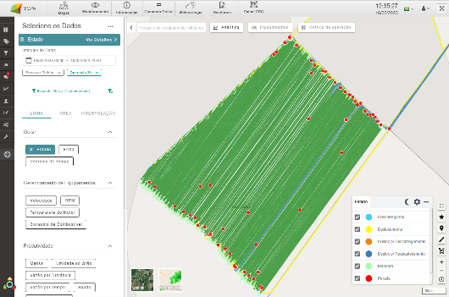

Changelog Version 2025/268

Period: 08/19/2025 to 09/01/2025

Revision 00

Date: 09/16/2025

Some applications mentioned in this report may not be available in the feature pack in your SGPA 3.0



Thank you for being a SGPA 3.0 user!

We update our system in order to fix bugs, improve performance and add new features to bring better user experience and contribute to a management with greater quality and efficiency.

**Table of Contents**

1. SGPA3 4

1.1 Specific Improvements 4

1.1.1 Tools - Integration 4

1.1.2 PBI Reports – General Daily 5

1.1.3 PBI Reports – Digital Certificate of Cotton 7

1.1.4 PBI Reports – Alarms 7

2.1 Bugs 8

2.1.1 Records – Implement Measurements 8

2.1.2 PBI Reports – Efficiency 9

2.1.3 PBI Reports – Cutting, Loading and Transporting Cane Online 9

2.1.4 PBI Reports – Supply (Cane) 9

# **SGPA3**

## Specific Improvements

### Tools - Integration

Adjustment made to the “Tools/Export - Harvester Monitor” report to change the description of the field nickname from “Roller Opening” to “Fuel Level” in all environments of the Sugarcane vertical.

Image 1 – Screen view for generating the “Tools/Export - Monit Harvesters” report

Image 2 – View of the exported report with the “Fuel Level” field

 Go to Main menu > Tools > Integration > Tools/export - Monit Harvesters > Date filters > Monit Harvesters field list > Fuel level

### PBI Reports – General Daily

Improvements to the General Daily Report for the Sugarcane Vertical, including a new Operations Group filter. The update was applied to both report tabs: Production Report and Operational Report.

With this update, users will be able to further refine their analysis by selecting transaction groups directly within the report.

Additionally, a new feature has been added to the Operational Yield chart in the Production Report tab. Now, in addition to analyzing Operational Yield (ha/h), it will also be possible to view Productive Operational Yield (ha/h).

To facilitate navigation and analysis, two buttons have been added to the report:

**Productive** → It shows the Productive Operational Yield (ha/h) indicator and the target to be entered now refers to this indicator.

**Operational →** Displays the Operational Yield (ha/h) indicator, and the target entered will be based on this indicator.

With this improvement, users can easily switch between the two views, obtaining a more detailed analysis of operational performance.

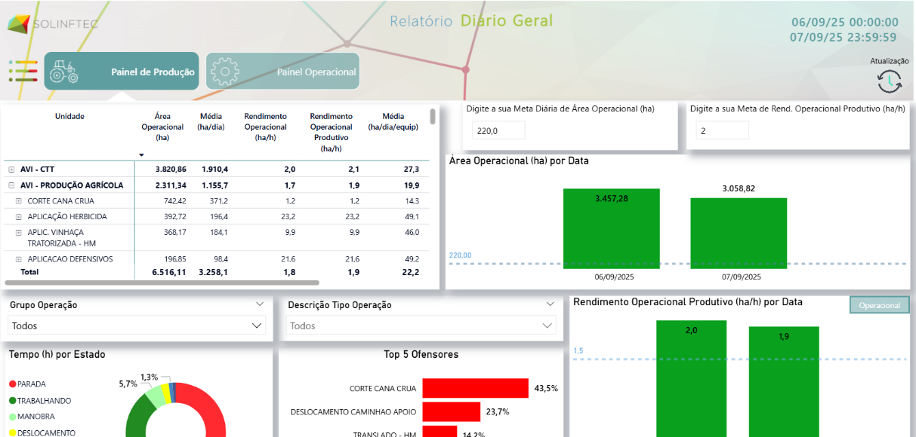

Image 3 – Daily Report – Production Panel – Operation Group

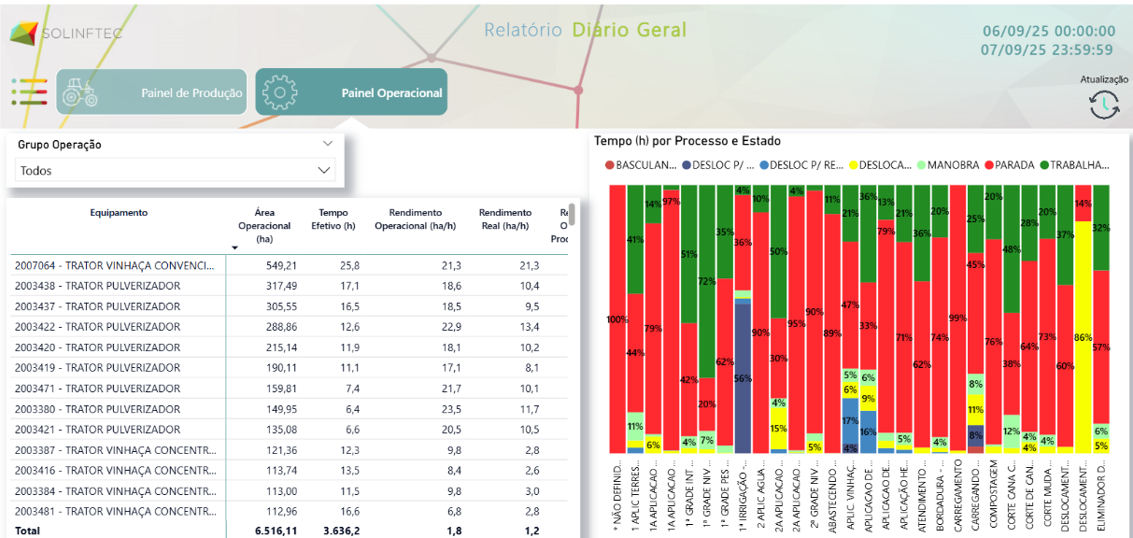

Image 4 – General Daily Report – Operational Panel – Operation Group

 Go to Main Menu > Reports > PBI > Map Reports > General Diary

### PBI Reports – Digital Certificate of Cotton

Adjustment made to display the break time of the productive day in the date range of the “Digital Certificate of Cotton” PBI Report.

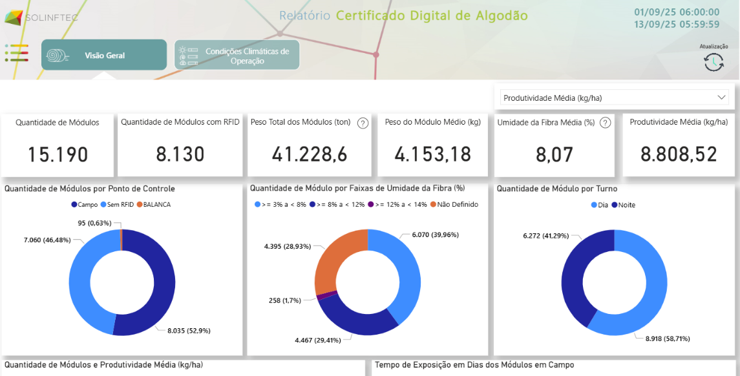

Image 5 – PBI Report “Digital Certificate of Cotton”.

Go to Main menu > Reports > PBI > Digital Certificate of Cotton

### PBI Reports – Alarms

Changes have been made to the Alarm reports for all three verticals to standardize the graph presentation. The graphs now show the productive time of day.

This change aims to avoid confusion between data presented based on the calendar day and the productive day, making the information clearer and more consistent directly in the report.

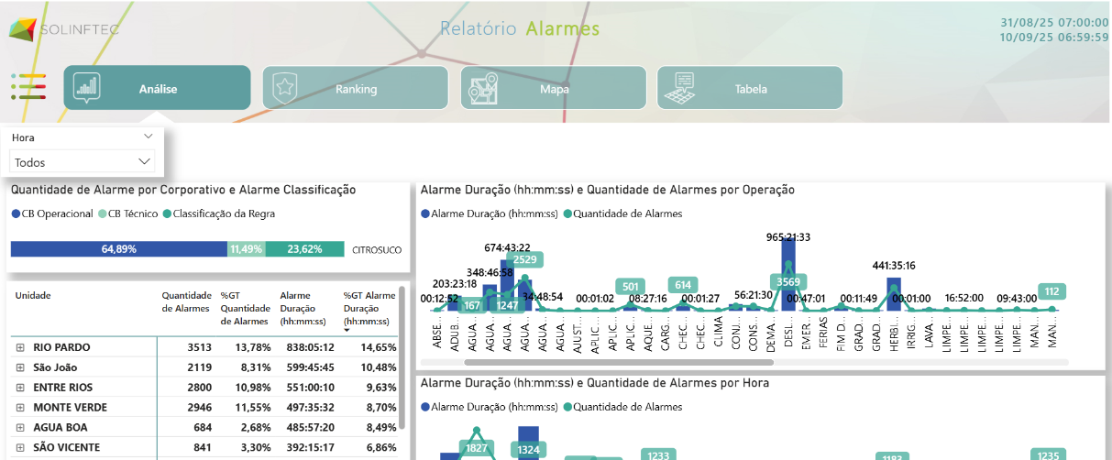

Image 6 – PBI Report “Alarms”

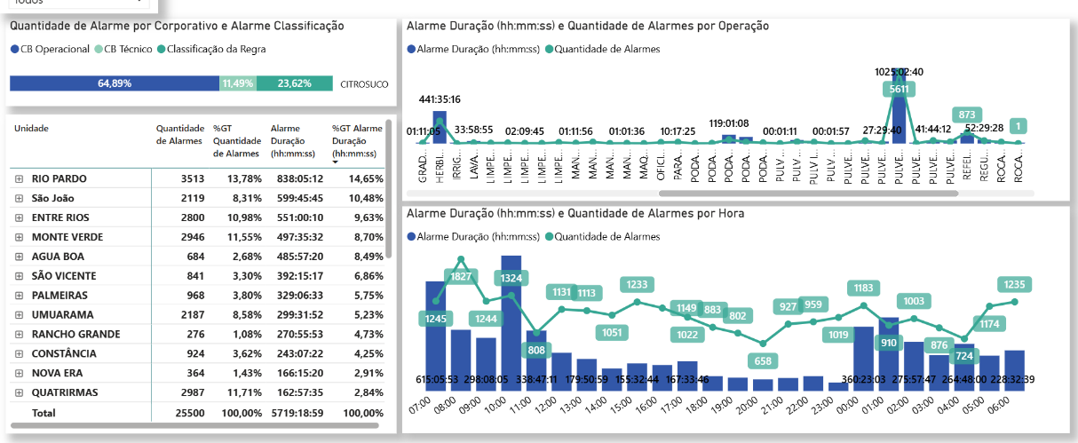

Image 7– PBI Report “Alarms”

 Go to Main Menu > Reports > PBI > Alarm Reports

## Bugs

### Records – Implement Measurements

Adjustment made to the "Implement Measurements" register, in the "1 - Sections" implement type to allow saving when filling in decimal values ​​in the "Section Spacing" fields.

 Go to Main menu > Records > Equipment > Implement measurements > Implement type > “1 – Sections” > Section spacing.

### PBI Reports – Efficiency

Adjustments made to the PBI Efficiency Report, for the Grains and Perennials verticals, in the “Hours Worked by Speed ​​Range” and “Hours Worked by RPM Range” graphs, to display the information correctly.

Go to Main menu > Reports > PBI > Efficiency

### PBI Reports – Cutting, Loading and Transporting Cane Online

Adjustment made to the PBI “CCT” Report (Cutting, Loading and Transporting Cane Online) to display the corresponding information in the popup of graphs, such as Idle Engine and Average Speed.

 Go to Main Menu > Reports > PBI > Online Reports > Cutting, Loading and Transporting Cane Online > Harvest Performance.

### PBI Reports – Supply (Cane)

Adjustment made to the Supply Report, Sugarcane Vertical, to change the order of the visuals in the report, making the "More Options" menu visible in the "Table" tab.

 Go to Main Menu > Reports > PBI > Supply > Table Tab

*In case of doubt or further clarification, please contact us via email* [*suporte@solinftec.com.br*](mailto:suporte@solinftec.com.br) *or call +55 18 3622 2270*